Lab name： **Subtractor Circuit (Differential Amplifier)** Student ID： B11102112 Name: Chiajui Lee

# Purpose

An OPA subtractor circuit is designed to perform subtraction on two or more input signals, producing an output signal equal to the difference between them. This design is useful for various applications, such as measuring signal differences or implementing amplifier adjustments.

# Steps

1. Construct the required circuit using operational amplifiers (OPAs) and resistors as specified in the problem.
2. Connect the power supply to provide +10V to the 𝑉+terminal and -10V to the 𝑉− terminal of the operational amplifier (OPA).
3. Measure the output results using an oscilloscope.

# Data

## Differential Amplifier

* 1. Circuit Diagram

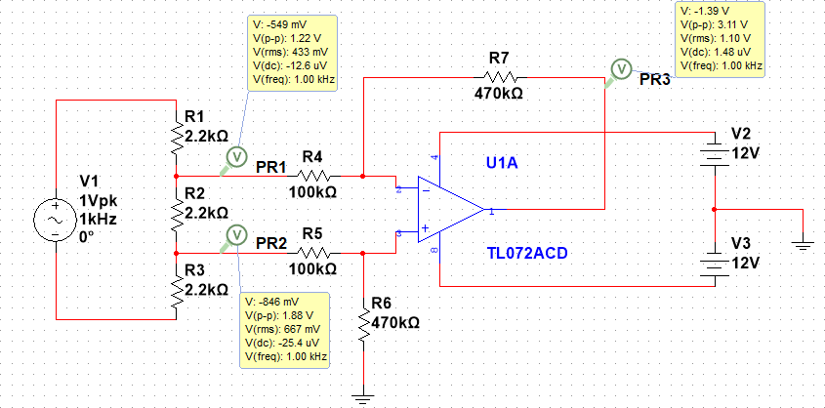

* 1. Output Value

|  |  |  |
| --- | --- | --- |
|  | Measured Value | Theoretical Value |
| Output voltage | 1.5V | 1.5V |

* 1. Output Result

When Vi1 = 680mV , Vi2 = 344mV ; Vo = 1.5V

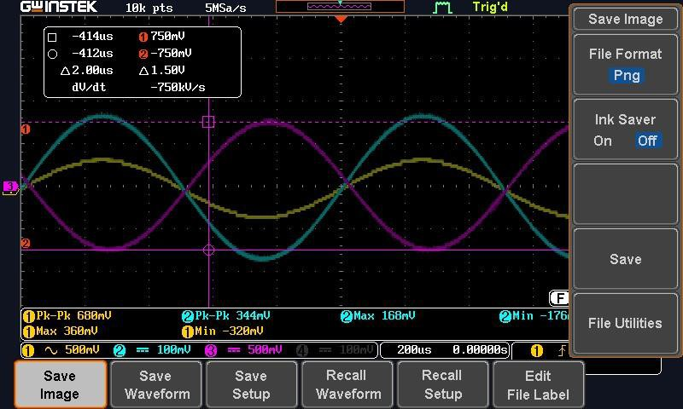

## Subtractor Circuit (Part 2)

1. Circuit diagram

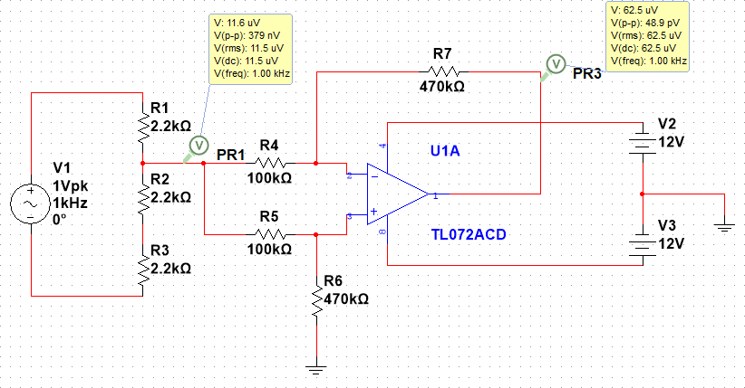

1. Output Value

|  |  |  |
| --- | --- | --- |
|  | Measured Value | Theoretical Value |
| Output voltage | 20mV | 12mV |

1. Output Result

When Vi1 = 680mV , Vi2 = 344mV ; Vo = 20mV

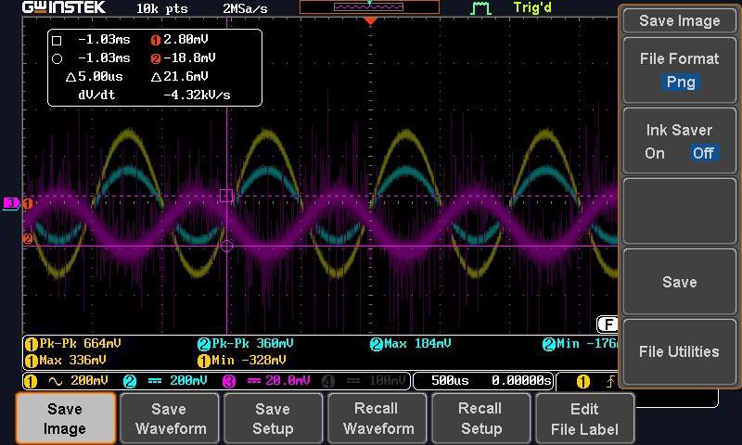

## Instrumentation Amplifier

1. Circuit diagram

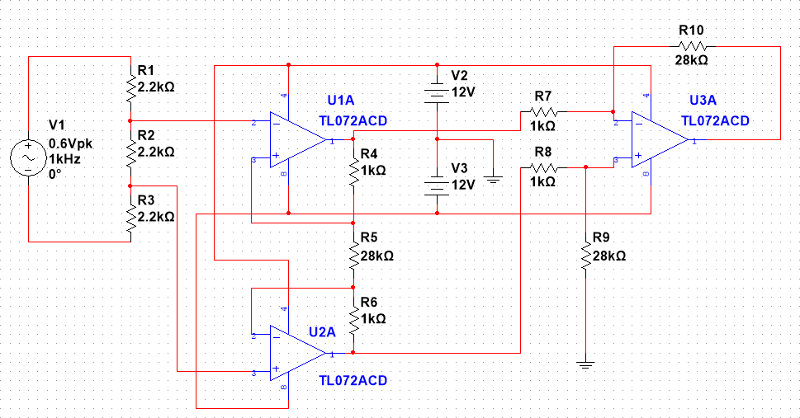

1. Output Value

|  |  |  |
| --- | --- | --- |
|  | Measured Value | Theoretical Value |
| Output voltage | 6.4V | 6V |

1. Output Result

When Vi1 = 448mV , Vi2 = 208mV ; Vo = 6.4V(AV = 30)

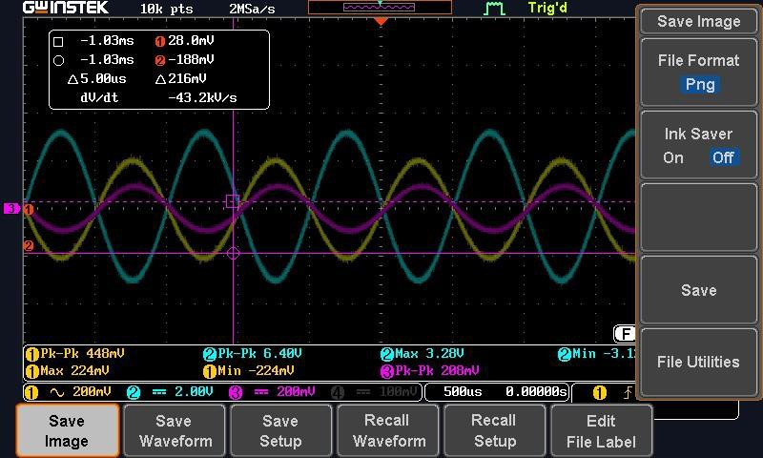

# Reflections

The focus of this practical session was to investigate the OPA subtractor circuit and its applications. The first circuit's relatively simple structure allowed us to complete the implementation smoothly. However, in the second circuit, the small amplitude of the input signal resulted in significant noise interference in the output signal. To accurately measure the output voltage, we applied the oscilloscope's cursor function learned in the previous lab session.

For the bonus task, we needed to design the resistor ratios independently. Initially, due to insufficient consideration, we selected too many resistors, causing oscillation in the output signal. Through discussions with classmates and subsequent adjustments, we successfully determined appropriate resistor ratios and achieved the expected output results.